LAB MANUAL

POINTERS AND DOUBLE POINTERS

WHAT ARE DOUBLE POINTERS?

A double pointer is a variable that points to another pointer which in turn, points to an object in memory.

Examples:
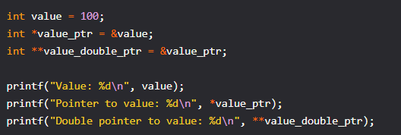

Output:
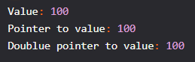
When dereferencing a double pointer, we do not get the final object, but what is expected: a pointer that must be dereferenced one more time to retrieve the final value. It would be similar to the code below.
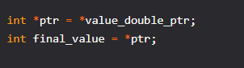

Tasks
1. Correct errors if any and Print Output
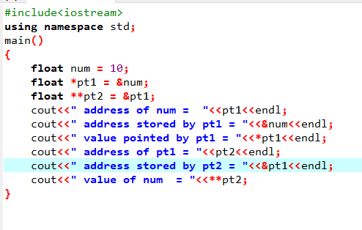
a)

b)

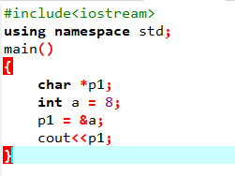

c)
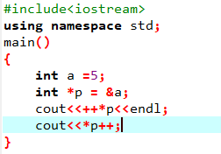

d)

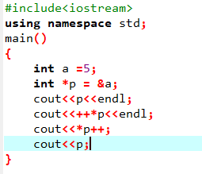

PROGRAM BASED QUESTIONS

🔸 Task 1: Pointer Basics
Write a program that:
- Declares an integer variable and a pointer to that variable.
- Prints the address and the value using the pointer.
- Modifies the value using the pointer and prints the updated value.
Expected Output:
Value of x: 10
Address of x: 0x...
Value using pointer: 10
Modified value: 20

🔸 Task 2: Pointer Arithmetic
Create an array of 5 integers. Use a pointer to:
- Traverse the array using pointer arithmetic.
- Print each value and its address.

Task 3: Swap Using Pointers
Write a function void swap(int* a, int* b) that swaps two integers using pointers.
Call it from main() and show the values before and after swapping.

Task 4: Double Pointers - Access and Modify
Write a program that:
- Declares an integer, a pointer to it, and a double pointer.
- Demonstrates accessing and modifying the value using both single and double pointers.
int x = 5;
int* p = &x;
int** pp = &p;
Modify x to 100 using **pp.

